Waves of the Kept Stone
“Fear arrives on the waves as the terrifying tower, the Sea’s Stone, unleashes a tide of lizardmen upon the unsuspecting coasts.”
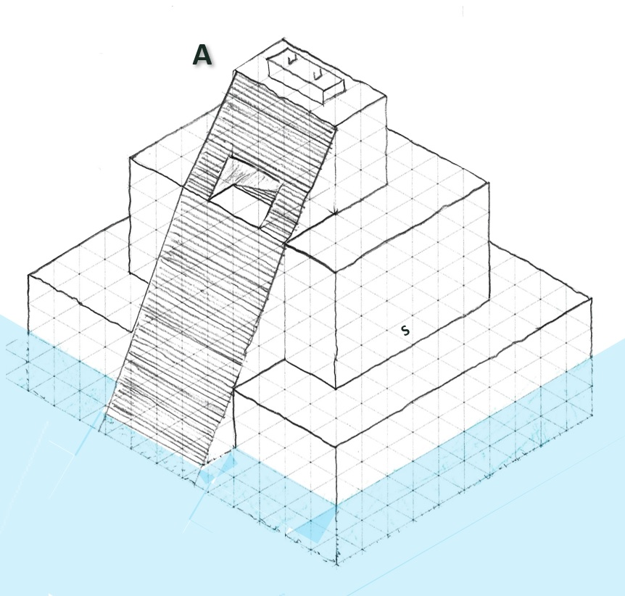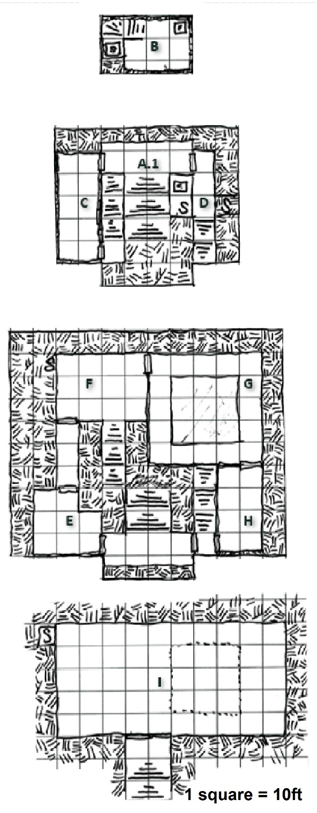
Once the temple of Aerhan-Chicahualiztli, the Spirit of Strength, as the god fell so too did the place. Now dedicated to Aerhan-Tlahuelli, Spirit of Rage, the temple was banished from the soil itself, banished to the seas by the Earthmother herself. But even so, the lizardmen dedicated to Aerhan found the temple and dedicated it to their god once more, the temple, now known as the Sea’s Stone, wanders from coast to coast. Always warlike, the lizardmen of the temple have intensified their raiding even more with the revolt of the mutant Stoneskins over the priests. Now magically powered by blood sacrifices, the Sea’s Stone teleports to helpless remote coastal regions at dawn, raids for captives, and leaves once more at dusk.
The Stoneskin lizardmen, enormous and rock-skinned, are born of normal lizardmen eggs regularly bathed in basilisk venom. A blinded cultch of basilisks are kept by the lizardmen and milked for their venom. Normally only a few eggs at a time were selected by the lizardmen for treatment but with the new Stoneskin chief Hhroah’hr in charge all the eggs are being treated, much to the resentment of the “normal” Greenscales.
Hooks, normally the adventure assumes it begins with the Sea’s Stone showing up at dawn and raiding:
Sea’s Stone shows up and your friends got kidnapped!
The Oracle of the Earthmother says her goddess wants to destroy the temple.
Aerhan high priest Angerhand Telos wants his sacred headdress.
PCs need a teleporting traveling temple that runs on blood.
Encounters on the way:
Punished Captive: Agonized and twisted moans echo through the mangroves. If investigated the moans come from a half-eaten young blacksmith left in the mud. His eyes, nose, one ear, lips, fingers, feet, and most of his large muscles have been eaten along with half his liver, it is a testament to his vast fortitude that he remains alive. If he senses anyone coming, he’ll beg for death through his mangled lipless mouth. If promised death or regenerative magic he’ll try to describe a raiding party’s composition. If healed somehow, he’ll seek to join to kill all the lizardmen (stats as a fighter 6 with 18 STR).
Deserting Basilisk Keeper: Loud mournful chirps indicate a small distressed Greenscale lizardman. Trapped beneath an enormous petrified boar that was in the midst of goring him, a bedraggled basilisk keeper looks with panic at any incoming warmbloods. If calmed down, via charade the lizardman will offer his smelly basilisk-goad (blinded basilisks will avoid the bearer) if freed. He holds one more basilisk venom dart (hold with metal or petrifies) and three rescued untreated eggs from the temple.
Greenscale Lizardman: HD2+1 (10hp), AC 5[14], Attacks: 1 x stone sword (1d6+1), THAC0 17[+2], Movement 60’ (20’), Morale 9
Priest Ssra’kiss: Lizardman Cleric HD4 (14hp), AC 5[14], Attacks: 1 x sacrifice club (1d6+1), THAC0 16[+3], Movement 60’ (20’), Morale 8, Spells: Cure Light Wounds, Remove Fear, Hold Person
Stoneskin Lizardman: HD4+1 (19hp), AC 5[14], Attacks: 2 x claws (1d8), THAC0 15[+4], Movement 60’ (20’), Morale 11, Stony Skin (halve all damage from physical attacks)
Chief Hhroah’hr: HD6+1 (28hp), AC 2[17], Attacks: 2 x great stone club (1d12), THAC0 13[+6], Movement 60’ (20’), Morale 12, Stony Skin (halve all damage from physical attacks)
Blinded Basilisk: HD3+1 (15hp), AC 6[13], Attack: 1* x bite (1d8+petrification), THAC0 16[+3], Movement 60’ (20’), Morale 8, Blind, but has excellent hearing and smell. Dislikes water.
The Sea’s Stone:
Sea’s Stone, a cursed temple dedicated to the fallen god Aerhan-Tlahuelli, is magically banished from ever being set upon the ground. Bloodily sacrificing a living sentient being upon the altar at the precise moment the setting sun touches the horizon will cause the temple to slowly glow blood-red and disappear into the dark void of Aerhan-Tlahuelli’s personal hell, to reappear where the sacrifice wills in a flash of golden light heralded with the sounds of ghostly sibilant chants at the precise moment of dawn the next day. If the temple has been looted, Aerhan’s rage is upon the place while within his hell and he sends demons against it through the night.
The temple radiates tropical warmth whatever temperature surrounding water is. Every half hour roll a d6 for a returning patrol, on a “1” a raiding party of one Stoneskin and four Greenscales, with 1d6-1 captives, return to the Sea’s Stone, deposit captives (I), and then set out again hunting. The temple’s thick walls don’t conduct sound easily, but loud noises can attract investigation; every time players act recklessly, in addition to drawing the next room over the GM should add another d6 to the return roll representing the chance of raiders being recalled, if four dice are present then immediately roll for an encounter. Half an hour before sunset, all six raiding parties return to the temple for its departure.
NPCs in the temple:
In addition to the 5ft-tall craven and resentful Greenscales and the 8ft-tall violent and haughty Stoneskins there are two leaders within the temple:
- Priest Ssra’kiss: Faithful to Aerhan but hates the upstart Hhroah’hr. Utterly contemptuous of the warm-blooded “food” that gets taken.
- Chief Hhroah’hr: Corpulent and gluttonous, Hhroah’hr hasn’t joined the raids in months and covers his worry for his position with bluster.
A. Outer Temple: Baking under the sun. Four blinded basilisks sleepily sun themselves on the first level, two of them flopped next to the secret door inward (D). The altar at the top of the temple is stained black with the blood of sacrifices and gleams with gold trim (worth 2,448gp if scraped). Near dusk the raiding parties return, and they along with Priest Ssra’kiss and Chief Hhroah’hr sacrifice a favored captive at the sunset, teleporting the Sea’s Stone away. The stairs down within the inner temple (A1) are trapped with a basilisk poison dart trap (THAC0 15[+4] if it hits save vs petrification as with basilisk) hole at head-height (4.5ft) for lizardmen, raiders entering and exiting bow below it to not set it off (Greenscales incline their heads, Stoneskins completely bend over).
B. Secret Priestly Room: Thick cloying incense covers the lizard musk of Priest Ssra’kiss, who spends his days in this room praying for the death of Chief Hhroah’hr and the return of his headdress of office (E). The priest is a coward who negotiates for his life and position if isolated in his room, but bold and implacably hostile if met in public (emerges at sunset). The room is modest but hidden within the priest’s hollow stone bed is a golden idol of Aerhan (worth 7,500gp in gold, or more to adherents) squirreled away from the shrine (F).
C. Sleeping Nests: Formerly a stately statuary hall, now stinks of lizardman musk as the rubble of three of the four statues that were here has been rearranged into nests where the lizardmen sleep in piles. If any raiding Greenscale lizardmen are wounded and break, they retreat here.
D. Hall of Secrets: This rank-smelling hall has a Greenscale lizardman with a basilisk-goad sleeping up against the wall with the secret door leading outside (A).
E. Chief Home: Chief Hhroah’hr squats here for most of the day, scratching at stony growths inflicted by the god’s ire. The enormous lizardman considers himself tactful and if confronted he’ll attempt to treat honorably, but he also marks the most delicious character (highest CON score) as a meal he must have. His personal lockbox, its lock shiny with a coating of basilisk venom, holds 213pp, 2,931gp, and 1,951sp. Sacred Headdress of the Sunset (worth 1,525gp to a collector or twice that to a worshiper) is under a pile of gravelly crap in the corner.
F. Ceremony Shrine: Walls once decorated by frescoes of athletes sporting, now marred by charcoal notes about the figures’ prime meat cuts. Against the north wall an ornate shrine (gold trim worth 1,024gp if scraped) festooned with flowers and bones that lacks a central idol (moved to B). Captives taken through this area are frisked; a bowl filled with clear basilisk venom holds 9pp, 193gp, 531sp, 312cp, and a petrified pet mouse. In the secret alcove to the northwest a marble statue with brilliant agate eyes (4,500gp if whole, 850gp for each eye by itself) from the hall (C).
G. Sacrifices’ Threshery: This torchlit room with blood-smeared frescoes echoes with cries and splashing from below. A narrow channel of oil runs the rim of the pit (I), to be lit each time a raiding party returns with captives. In the southwest corner a Stoneskin lizardman sits on an oil barrel; he refills the little trench. If threatened, he’ll roll the heavy barrel across the platform to knock enemies over into the pit. Along the eastern wall are fifteen treated lizardman eggs (worth 200gp each to a slaver or particularly perverse gourmand).
H. Basilisk Nests: Formerly an ornate bathing room painted with elaborate frescoes of athletes the room’s three dented bronze tubs (worth 515gp each) are now covered in stony crushed bones from the basilisks who use them as nests. A pair of Greenscale lizardmen in oversized metal boots and mismatched plate gauntlets gingerly dip three big eggs into a beautiful ceramic cauldron (worth 1,150gp if unchipped) filled with venom milked from the basilisks. If surprised, the lizardmen with kick over the cauldron, dumping out the venom throughout the room, turning any cloth or leather footwear to stone. The lizardmen fight with one using a lasso and the other using the Enucleation Prod, a special rod used to remove eyes (if it hits, does 1d4 damage and removes an eye).
I. Pit of the Lost: On the stairs leading down to this sodden basement (2ft of salt water, urine, and feces), two venom basilisks appear to sleep, save for their forked tongues flicking out. They’ll bite passing warmbloods but avoid the sludge. Initially a dozen terrified captives are kept here, half with broken arms or legs, but more may be added as raiders return. In the back corner the notably more ragged prisoner Tam Duggers hunches and giggles; he wears a Ring of Invisibility that he uses whenever the hungry lizardmen come for meals. Beneath him hidden in the sludge under a loose stone are the valuables he’s scrounged from dead captives over the months (45pp, 831gp, 2,173sp, 197,012cp, 312 small gems worth an average of 10gp).

